# Cpanel Deployment Live Server Step By Step Deployment Documentation:

1. First of all, we need to compress (type:zip) the whole laravel project which u want to host in the live server.
2. Then after the compressing of the folder is done we then have to login in cpanel and after the login is completed search for the file manager option in the files heading. Click on files manager and then the page will redirect u too the storage folder of cpanel.
3. If u want to create the sub-domain for your page then u have to create a sub-domain from the domain heading in the home page. Then after selecting sub-domain u need to create the name for your sub-domain and it will create a new folder in your storage of cpanel and then give the redirection link too in it.
4. If u want to show the app in main domain then u have to upload the file u compressed in and extract it inside the public_html and wait for it to upload. After the upload is done move all the files except mix-manifest.json to the public_html directory.
5. If u want to show the app in sub-domain then go to the subdomain folder and the compressed file and extract it inside that folder, and do same as above.
6. After the project is extracted and the public folder is moved to the root directory for the live server, go back to the cpanel home directory and create a database where your whole projects database is going to be stored for live server. To create a database go to databases heading in the cpanel and there u can see MySQL® Databases subheading inside it and click that heading this will redirect u too page to create a database.
7. After you get redirected to that page just input the criteria for creating database and after you have done that successfully you can browse the database u have created just now by going back to the database section in cpanel home url and click on php my admin. There you can see the database name that you have created just now.
8. After you have realized that the database is successfully created the database go to the .env file which might be hidden in the storage of inside your page folder. Change the database name, username and password according to your database.
9. Then after editing the .env file u are good to go, search for the domain or subdomain you have created.

**Thank you!!!**

# Cpanel image slider issue in gbho project:



1. The issue here was the path we had given to show image slider was incorrect because the file was created in public folder but the path to show had directly storage path so the image was not shown.
2. the code sin filesystem should be changed.

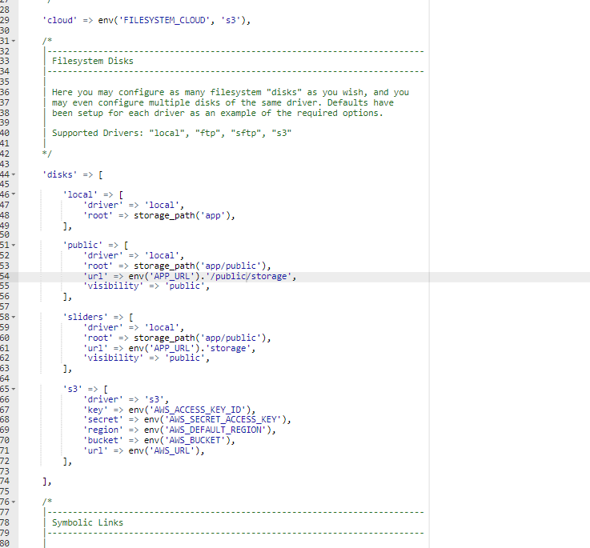

1. so we fixed the path to public folder from the code and it worked

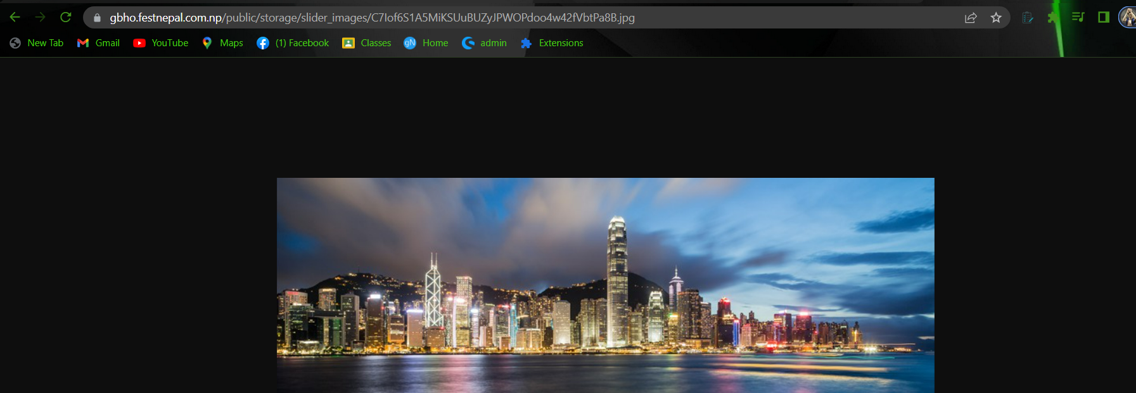

**Thank you!!!**

# 

*Documentation by:*

***Saugat******Pandey***